How parents and students can access Clever to get the links for online resources:

1. Go to the Montrose homepage <http://masd.info/>
2. Hover over the student tab and choose Clever 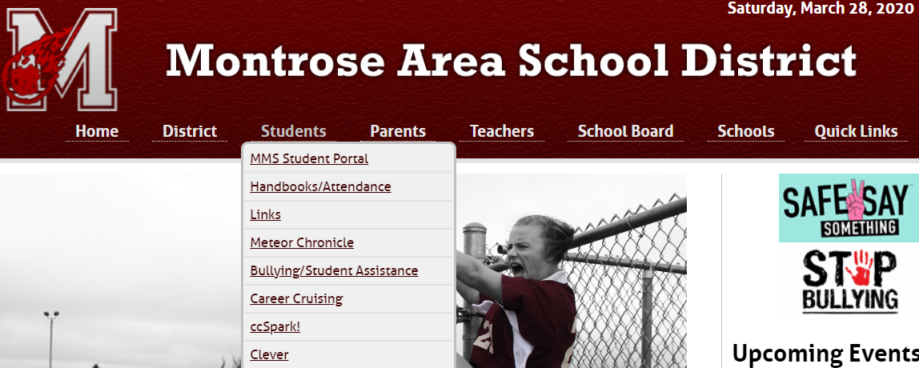
3. If the screen below appears follow these directions. If your screen doesn’t look like below go to step 4. If you have your child’s QR Clever badge you can use that to login. If you don’t have a camera on your device choose “Log in.” 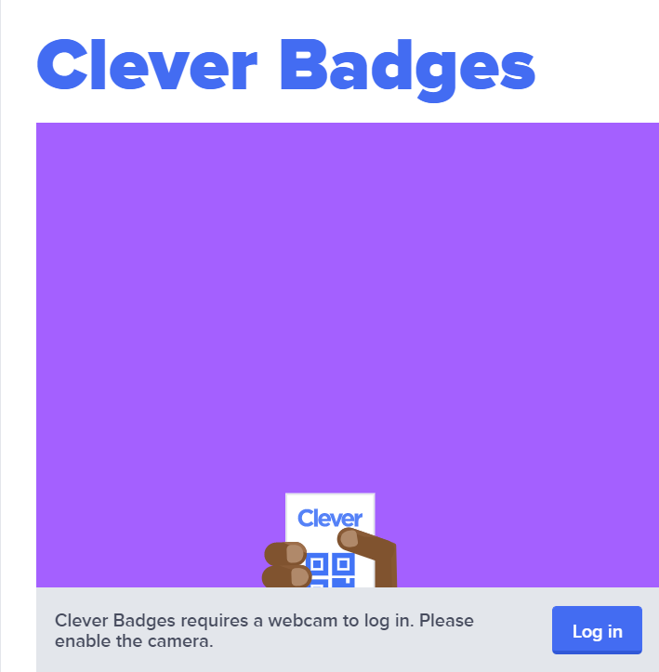
4. If the screen that is displayed looks like this one below there are a few options. Once again if you have your child’s QR badge you can choose Clever Badge log in. If you cannot do that choose “Log in with Active Directory.” 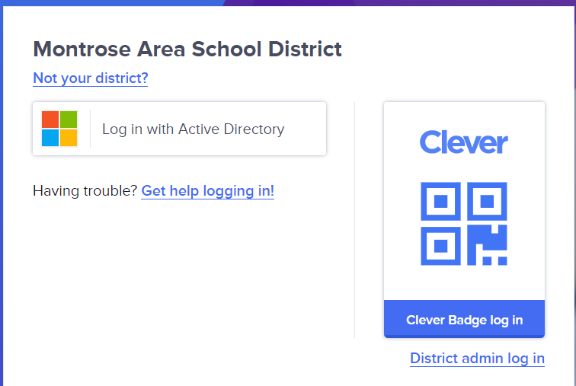
5. To Log in with Active Directory you will need to use your child’s email address. In most cases it is first initial first name and then last name (i.e. [psmith@masd.info](mailto:psmith@masd.info)) and then their password.
6. Once in you will see a page like this. 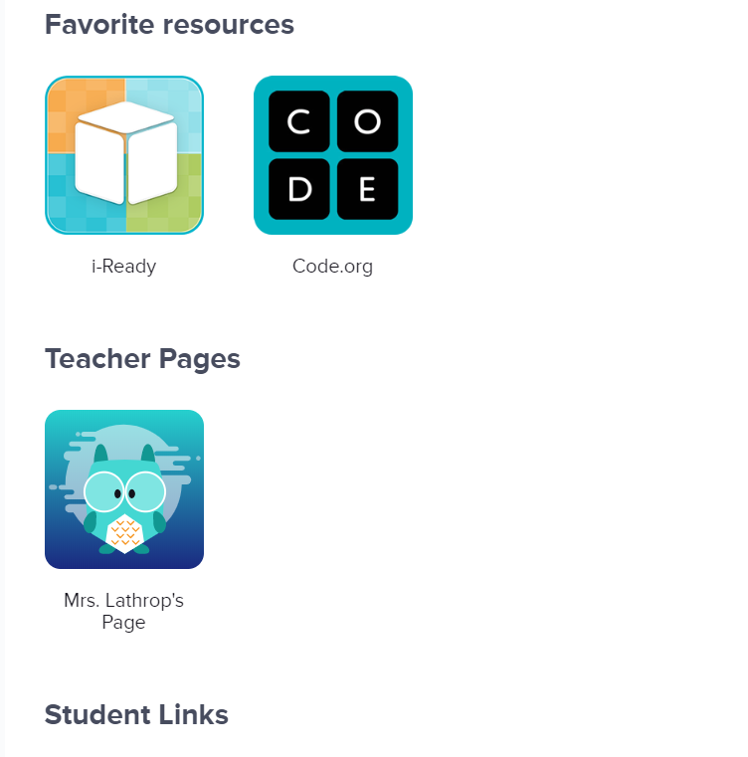
7. From here you can get to your child’s teacher’s page where their Google Classroom link is likely to be found.
8. This is also where you will find the link to i-Ready. You can click on the i-Ready icon and it will open for them “Choose a Subject.” 